Module 8) JavaScript Essentials &

Advanced

Q.1) Using console.log() print out the following statement: The quote 'There is no exercise better for the heart than reaching down and lifting people up.' by John Holmes teaches usto help one another. Using console.log() print out the following quote by Mother Teresa:

Ans.1) 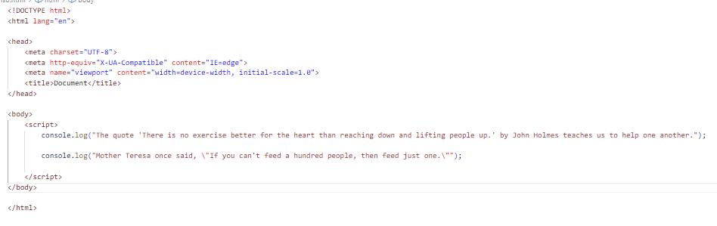

Output: 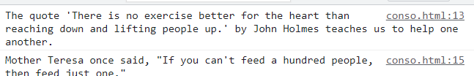

Q.2) Check if typeof '10' is exactly equal to 10. If not make it exactly equal?

Ans.2)

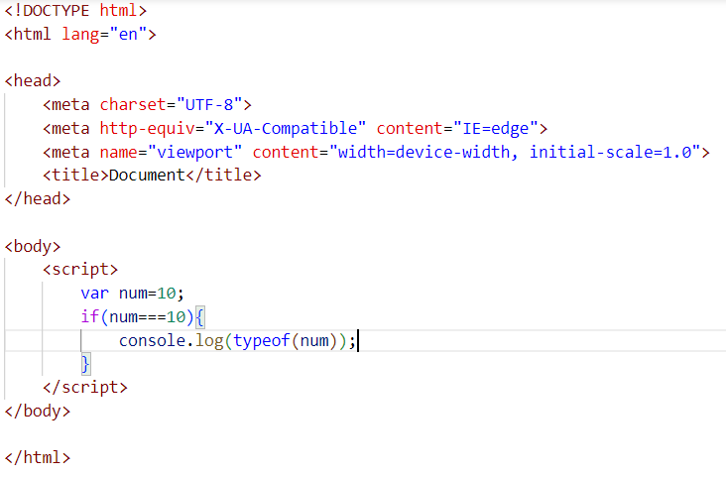

Output:

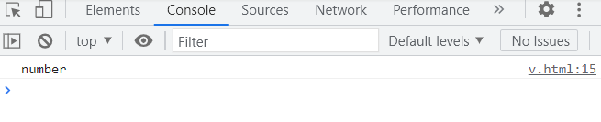

Q.3) Write a JavaScript Program to find the area of a triangle?

Ans.3)

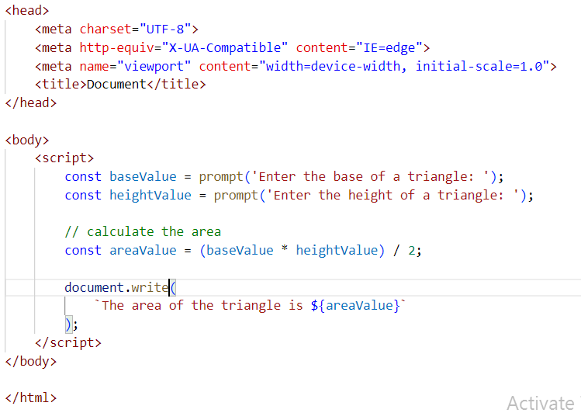

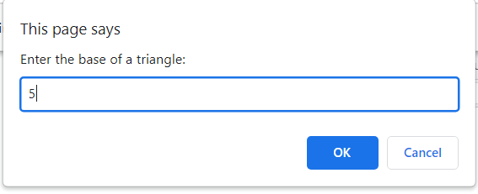 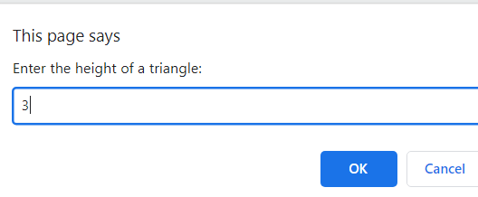

Output: 

Q.4) Write a JavaScript program to calculate days left until next Christmas?

Ans.4)

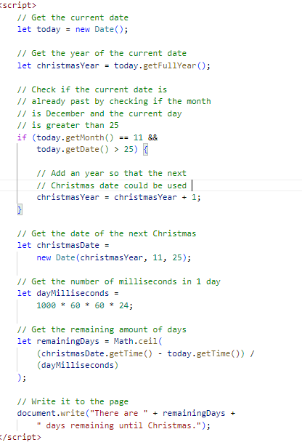

Output:

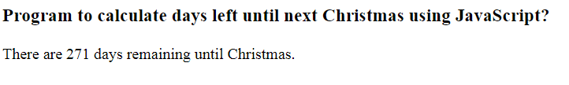

Q.5) What is Condition Statement?

Ans.5) In A JavaScript we have three forms of statement.

* if statement
* if else statement
* else if statement

1)if statement

* The if statement evaluated the condition inside the ().
* if the condition is evaluated to true , the code inside the body of if executed the code is

not executed

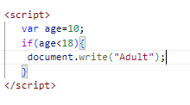

2) if else statement:

* The else statement is used to specify a block of code to be executed if a condition is not met.

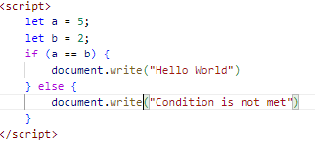

Output:



3) else if statement:

The else if statement is used to specify a new condition to be tested if the first condition is not met. This can be used when there’s more than one condition to be tested.

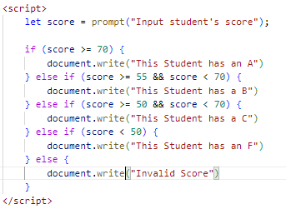

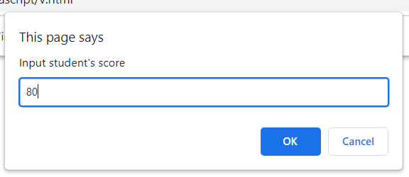

Output:



Q.6) Find circumference of Rectangle formula: C = 4 * a?

Ans.6)

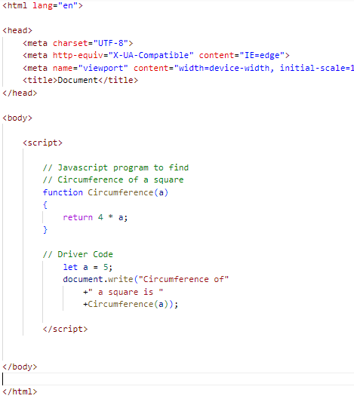

Output:



Q.7)WAP to convert years into days and days into years?

Ans.7)

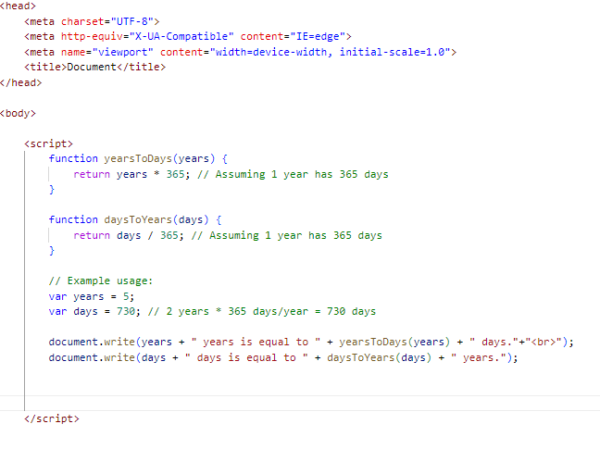

Output:



Q.8)Convert temperature Fahrenheit to Celsius? (Conditional logic Question).

Ans.8)

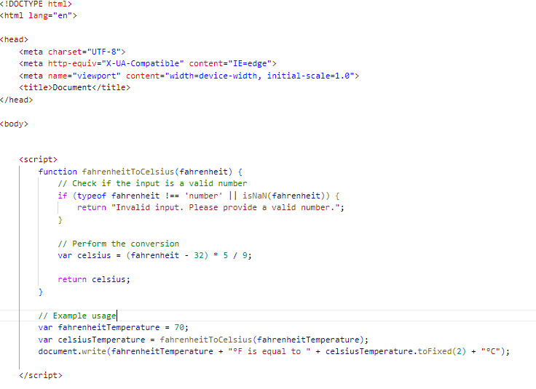

Output:



Q.9) Write a JavaScript exercise to get the extension of a filename.?

Ans.9)

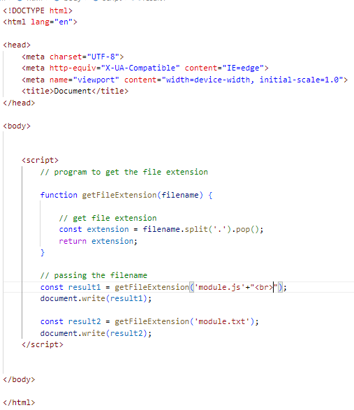

Output:



Q.10)What is the result of the expression (5 > 3 && 2 < 4)?

Ans.10)

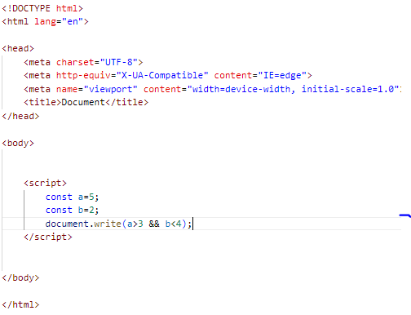

Output:



Q.11)What is the result of the expression (true && 1 && "hello")?

Ans.11)

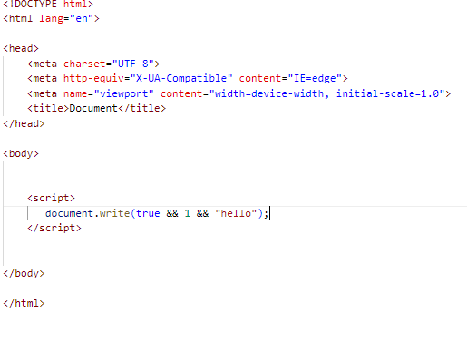

Output:



Q.12) What is the result of the expression true && false || false && true?

Ans.12)

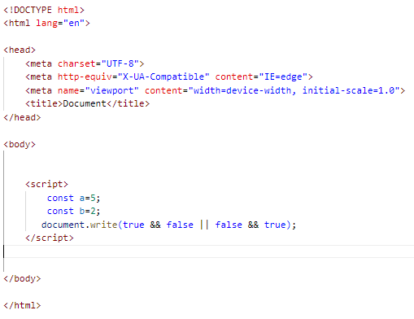

Output:



Q.13) Check Number Is Positive or Negative in JavaScript?

Ans.13) The Math.sign() method returns whether a number is negative, positive or zero.

If the number is positive, this method returns 1.  
If the number is negative, it returns -1.  
If the number is zero, it returns 0.

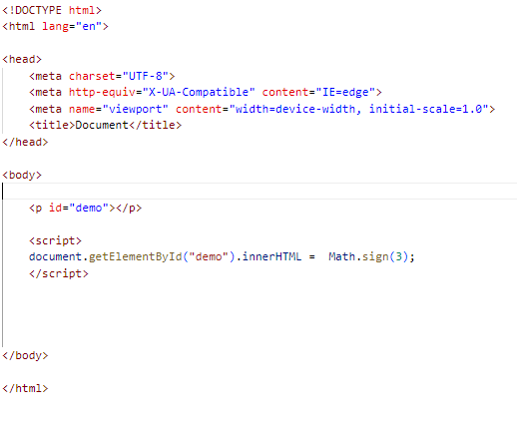

Output:



Q.14) Find the Character Is Vowel or Not ?

Ans.14)

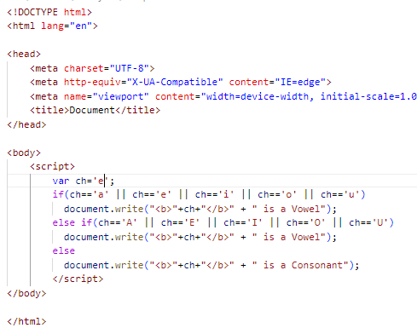

Output:



Q.15) Write to check whether a number is negative, positive or zero?

Ans.15)

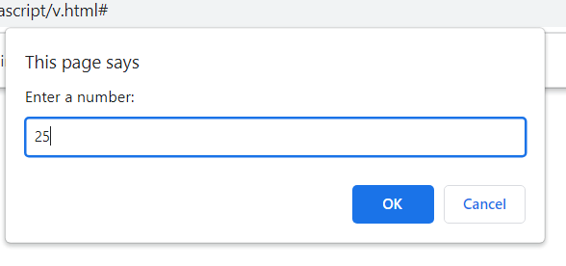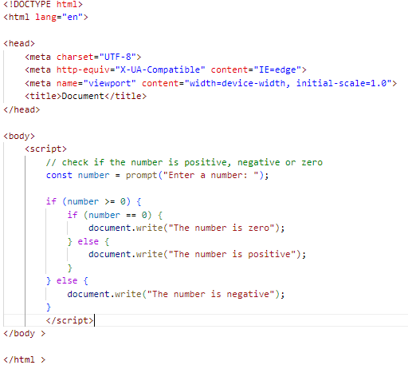

Output:



Q-16) Write to find number is even or odd using ternary operator in JS?

Ans.16)

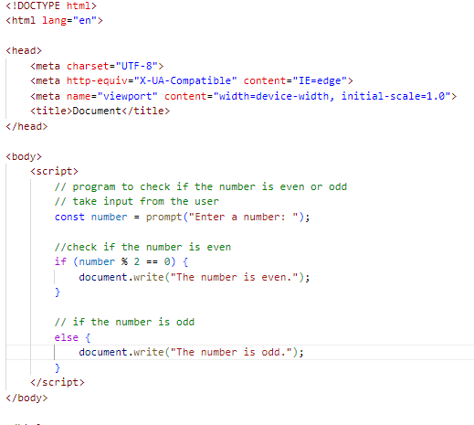

Output:

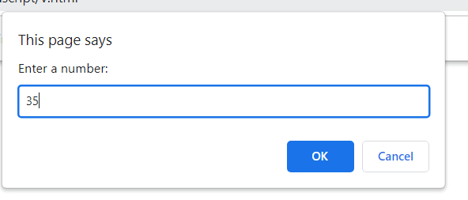

Q.17) Write find maximum number among 3 numbers using ternary operator in JS?

Ans.17)

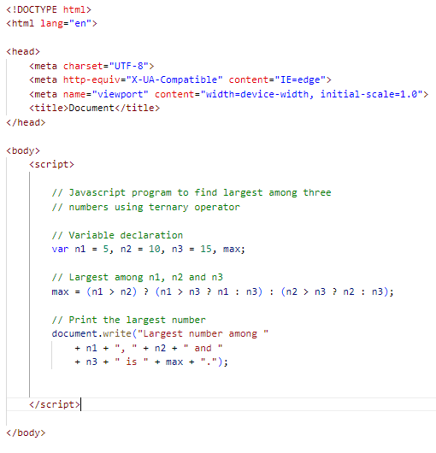

Output:



Q.18) Write to find minimum number among 3 numbers using ternary operator in JS?

Ans.18)

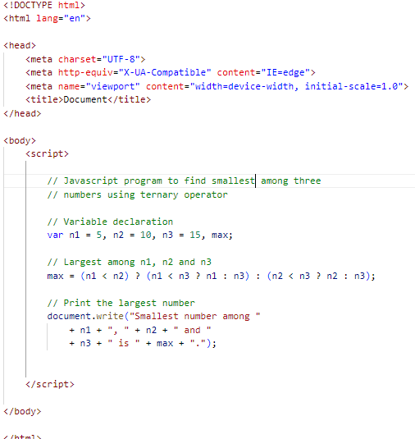

Output:



Q.19)Write to find the largest of three numbers in JS?

Ans.19)

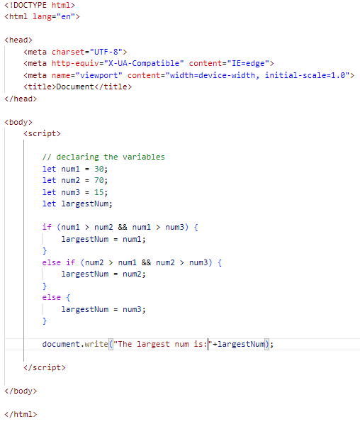

Output:



Q.20) Write to show?

i. Monday to Sunday using switch case in JS?

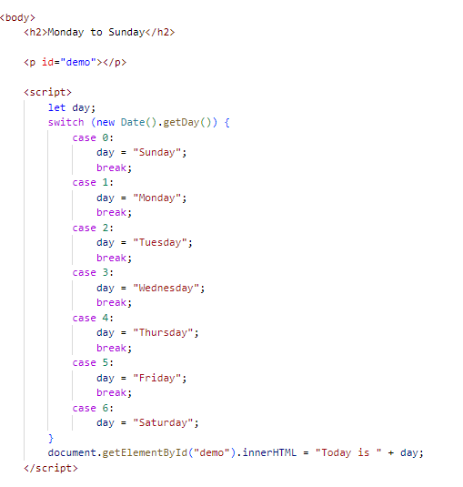

Output:

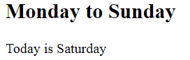

ii. Vowel or Consonant using switch case in JS?

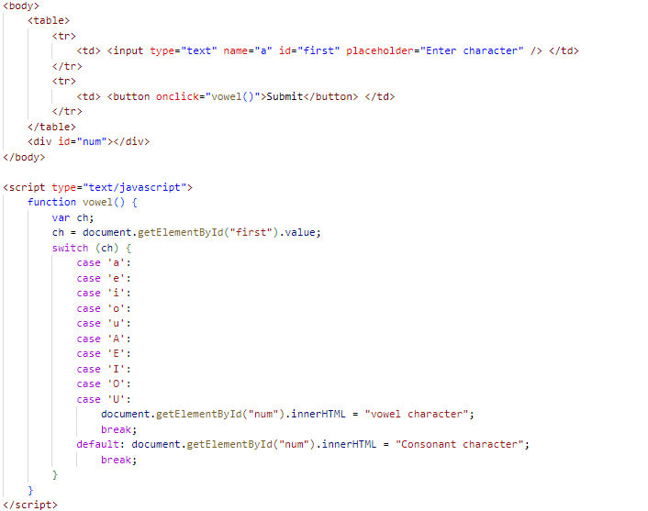

Output:

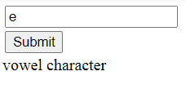

(Conditional looping logic Question)

Q.21) What are the looping structures in JavaScript? Any one Example?

Ans.21) we use loops to perform repeated actions. For example - if you are assigned a task of printing numbers from 1 to 100, it will be very hectic to do it manually, loops help us automate such tasks.

* types of loops:
* for loop
* for in loop
* for of loop
* while loop
* do-while loop

The for loop:

the syntax of a for loop something like this.

for(statement1;statement2;statement3)

{

//code to be executed;

}

example:

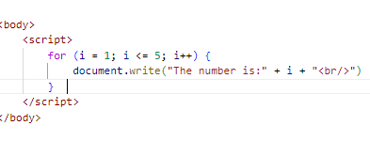

Output:

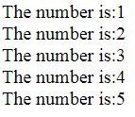

Q.22) Write a print 972 to 897 using for loop in JS?

Ans.22)

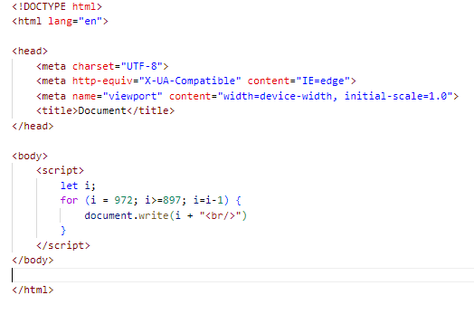 

Q.23) Write to print factorial of given number?

Ans.23)

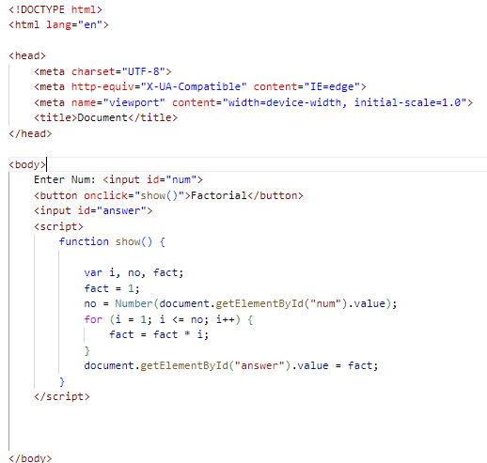

Output:



Q.24)Write to print Fibonacci series up to given numbers?

Ans.24)

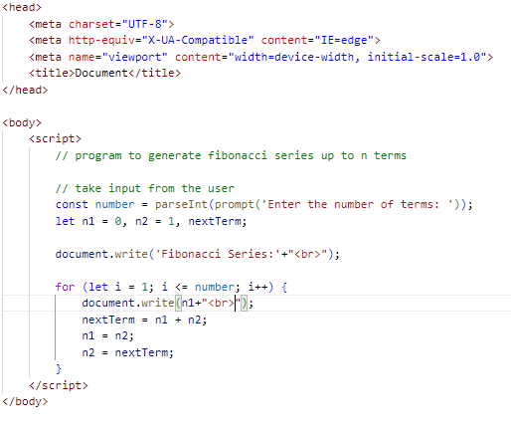

Output:

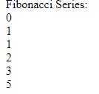

Q.25) Write to print number in reverse order e.g.: number = 64728 ---> reverse =82746 in JS?

Ans.25)

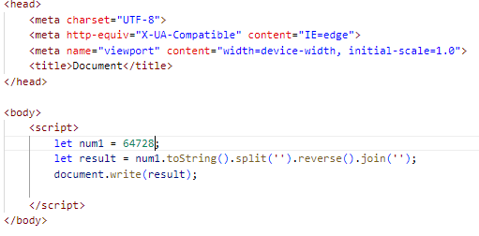

Output:



Q.26) Write a program make a summation of given number (E.g., 1523 Ans: - 11) in JS?

Ans.26)

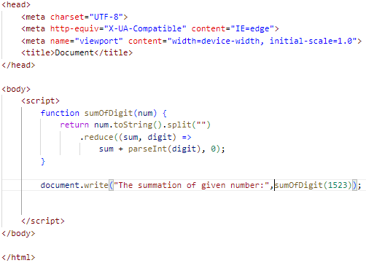

Output:



Q.27) Write a program you have to make a summation of first and last Digit.

(E.g., 1234 Ans: - 5) in JS?

Ans.27)

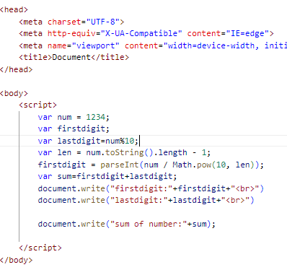Output:

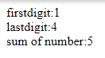

Q.28) Use console.log() and escape characters to print the following pattern in JS?

1 1 1 1 1

2 1 2 4 8

3 1 3 9 27

4 1 4 16 64

5 1 5 25 125

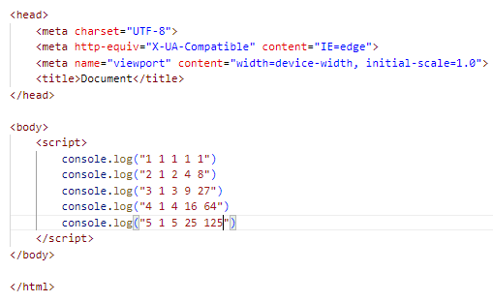

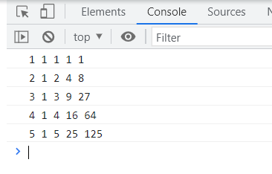

Q.29) Use pattern in console.log in JS?

1) 1

1 0

1 0 1

1 0 1 0

1 0 1 0 1

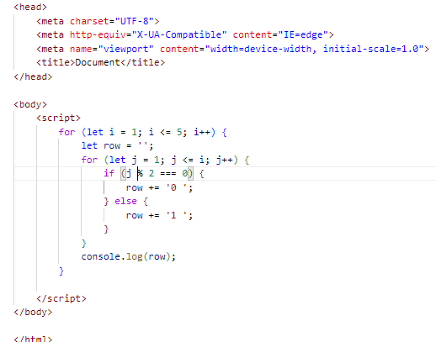

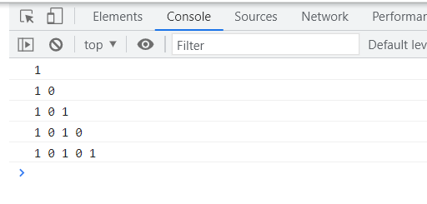

2)A

B C

D E F

G H I J

K L M N O

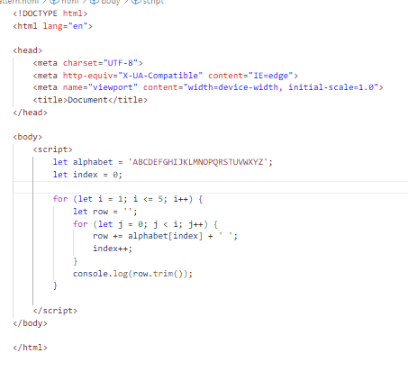

Output:

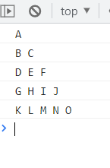

3) 1

2 3

4 5 6

7 8 9 10

11 12 13 14 15

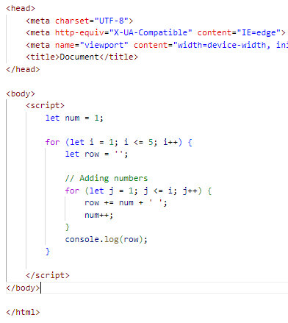

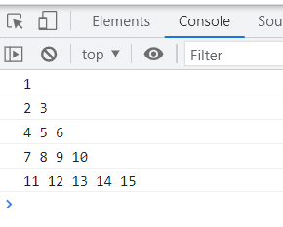

4) *

* *

* * *

* * * *

* * * * *

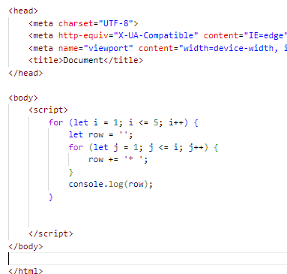

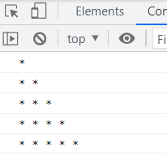

Q.30) Accept 3 numbers from user using while loop and check each numbers palindrome?

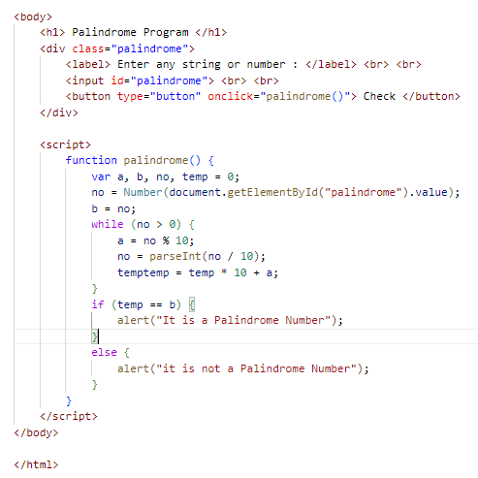

Output:

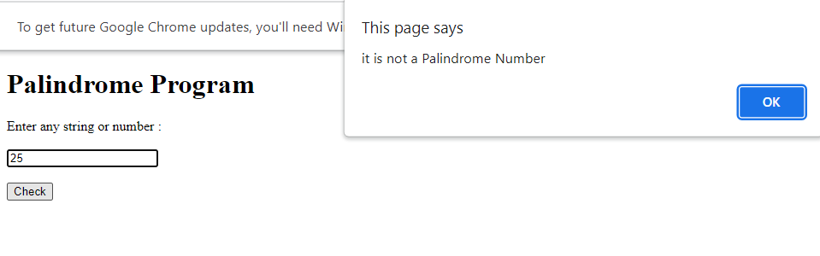

Q.31) day Write a JavaScript Program to display the current and time in the following format. Sample Output: Today is Friday. Current Time is 12 PM: 12 : 22 2 ?

Ans.31)

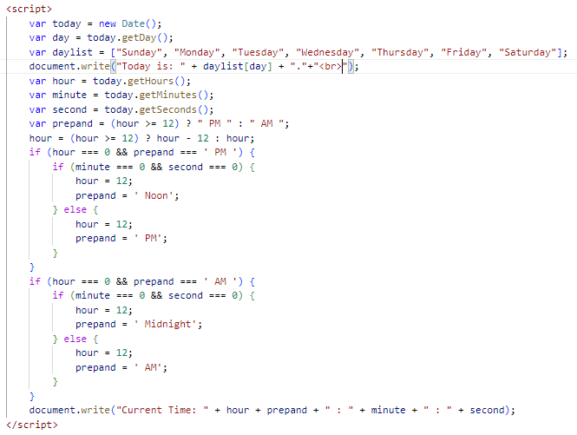

Output:



Q.32) Write a JavaScript program to get the current date?

Ans.32)

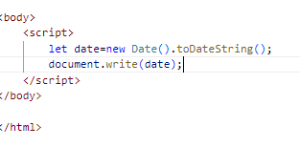

Output:



Q.33) Write a JavaScript program to compare two objects?

Ans.33)

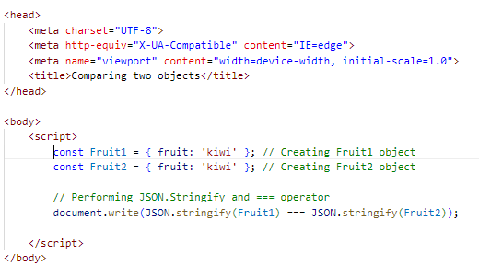

Output:



Q.34) Write a JavaScript program to convert an array of objects into CSV string?

Ans.34)

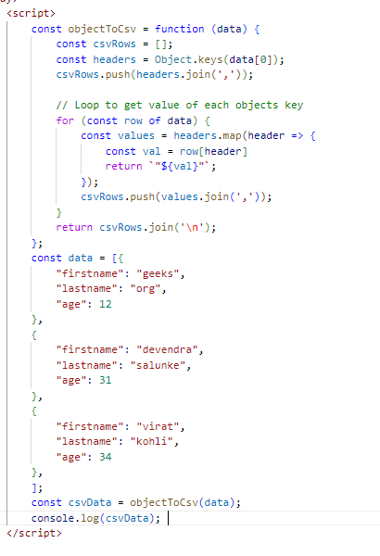

Output:

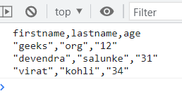

Q.35) Write a JavaScript program to capitalize first letter of a string?

Ans.35)

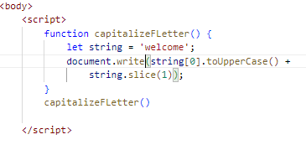

Output:



Q. 45)Write a JavaScript program to determine if a variable is array?

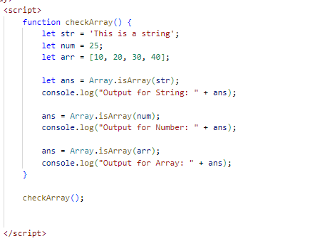

Output:

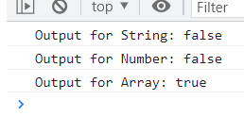

Q.46)Write a JavaScript program to clone an array?

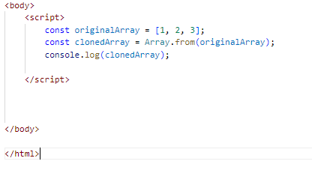

Output:



Q.47 )What is the drawback of declaring methods directly in JavaScript objects?

A-47) One potential drawback of declaring methods directly in JavaScript objects is that it can lead to increased memory usage, especially when you have multiple instances of the object.

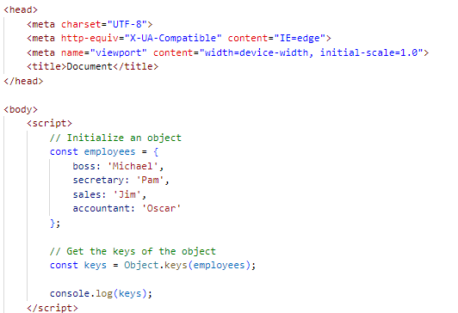

Output:



Q.48) Print the length of the string on the browser console using console.log()?

Ans.48)

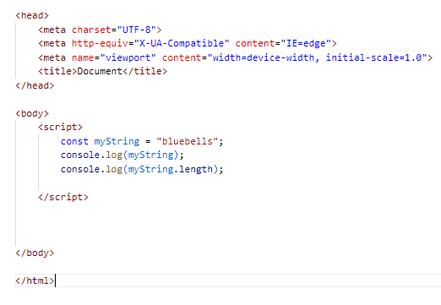

Output:

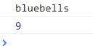

Q.49 Change all the string characters to capital letters using toUpperCase() method?

Ans.49)

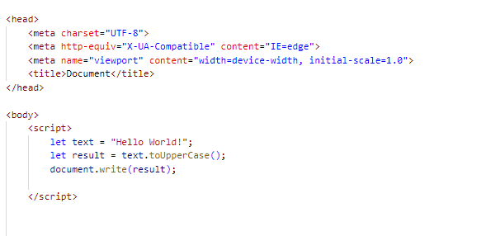

Output:



Q.50)What is the drawback of declaring methods directly in JavaScript objects?

Ans.50)

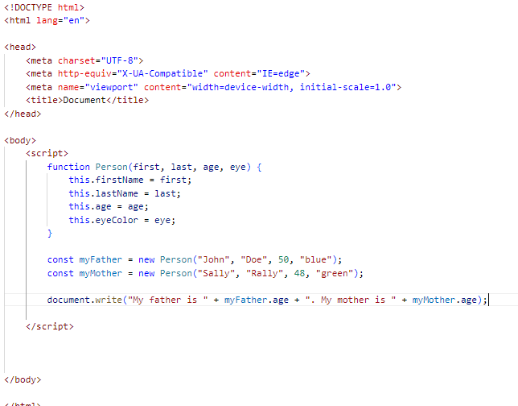

Output:



Q.51) Write a JavaScript program to get the current date.

Expected Output: mm-dd-yyyy, mm/dd/yyyy or dd-mm-yyyy, dd/mm/yyyy?

Ans.51)

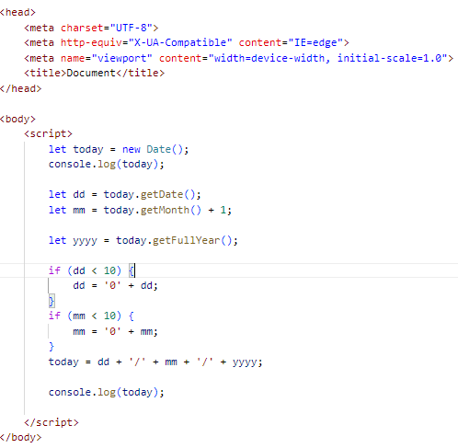

Output:

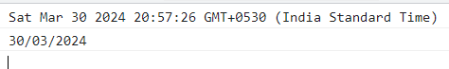

Q.52) Use indexOf to determine the position of the first occurrence of a in 30 Days Of JavaScript?

Ans.52)

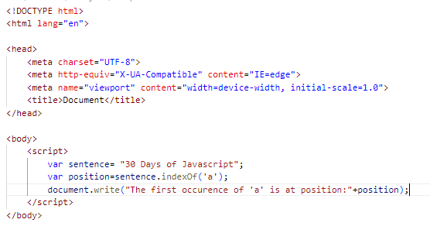

Output:



Q.53) Use lastIndexOf to determine the position of the last occurrence of a in 30 Days Of JavaScript?

Ans.53)

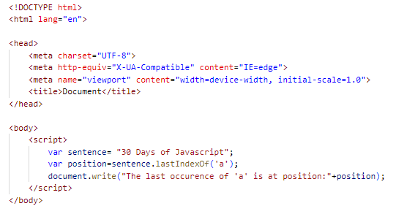

Output:



Q.54)Form Validation in JS?

Ans.54) Form validation is the process of verifying that the data entered into an HTML form is accurate, complete, and meets the specified criteria.

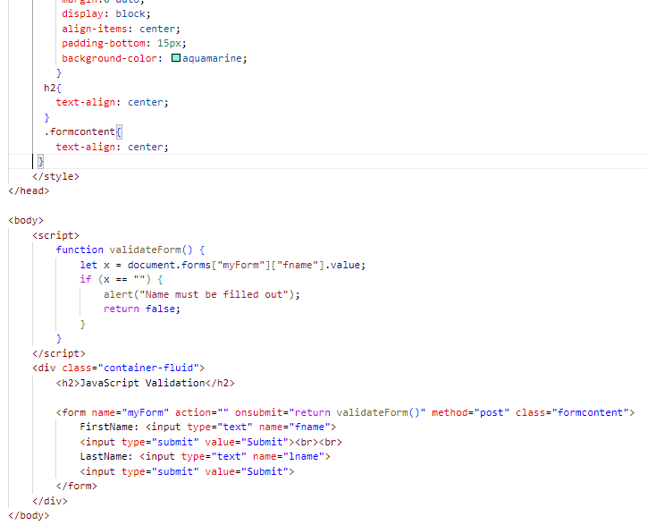

Output:

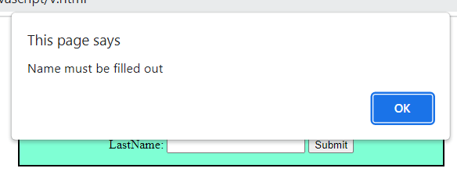

Q.55)Form in Email, number, Password, Validation?

Ans.55)

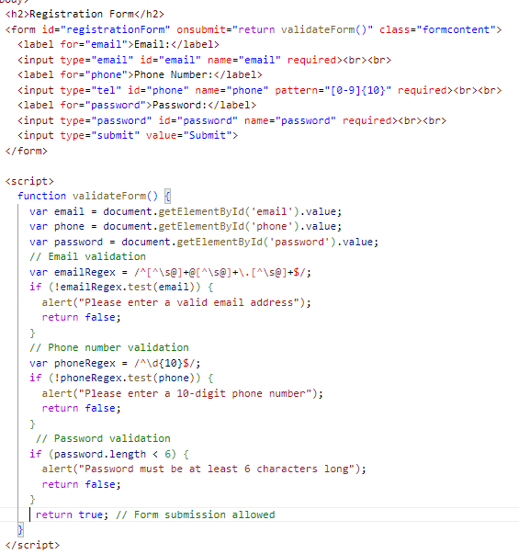

Output:

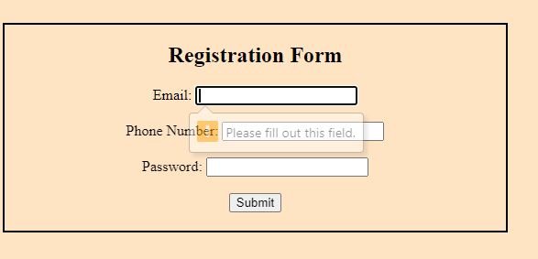

Q.56)Dynamic Form Validation in JS?

Ans.56)

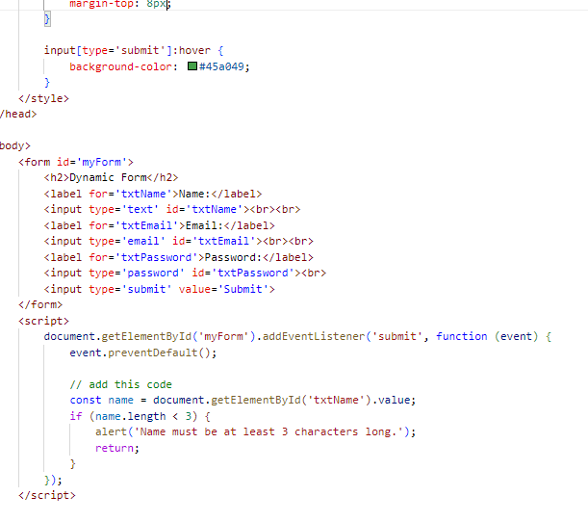

Output:

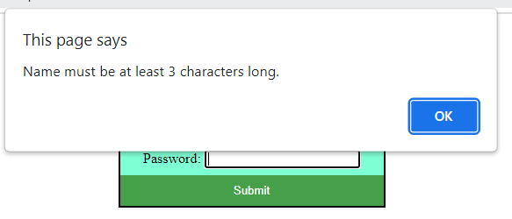

Q.57) how many type of JS Event? How to use it?

Ans.57) JavaScript has Event to provide a dynamic interface to a webpage. These events are

hooked to element in the Document object model.

* Common JavaScript Events
* Mouse Events: Event Performed. Event Handler. Description. click. onclick. ...
* Keyboard Events: Event Performed. Event Handler. Description. Keydown & Keyup. ...
* Form Events: Event Performed. Event Handler. Description. focus. ...
* Window or Document Events: Event Performed. Event Handler. Description. load.

* onclick Event Type : This is the most frequently used event type which occurs when a user clicks the left button of his mouse. You can put your validation, warning etc., against this event type.

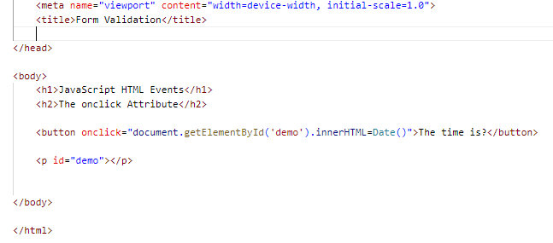

Output:

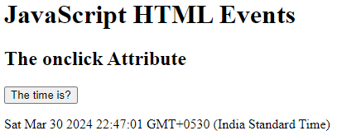

* onsubmit Event type :onsubmit is an event that occurs when you try to submit a form. You can put your form validation against this event type.

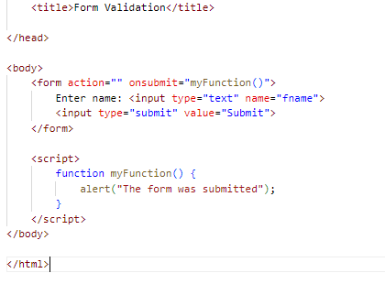

Output:

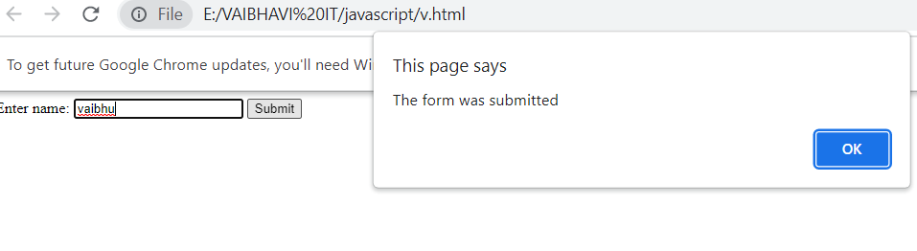

Q.60) What is Bom vs Dom in JS?

Ans.60)

| Document Object Model (DOM) | Browser Object Model (BOM) |
| --- | --- |
| It mainly focuses on the structure of the displayed document. | It mainly focuses on browser-specific functionality. |
| It facilitates a standardized interface to access and modify the elements and content of an HTML or XML document. | It allows JavaScript to interact with browser features beyond the scope of manipulating the document structure. |
| When an HTML document gets loaded in the browser, then it becomes a document object. | In this case, the window object will be created automatically by the browser. |
| It facilitates access and manipulation, along with dynamically updating the structure, content, and styling of the web document. | It facilitates the different functionality for governing the browser window, handling the navigation, managing history, and accessing browser-related information. |
| It provides direct access control to the content of the web document, along with permitting the traversal and modification of its elements and attributes. | It doesn’t have any access to the content of the web document directly. |

Q.61) Array vs object defences in JS?

Ans.61)

|  |  |
| --- | --- |
| Array | Object |
| Arrays are a special type of variable that is also mutable and can also be used to store a list of values. | Objects represent a special data type that is mutable and can be used to store a collection of data. |
| We use arrays whenever we want to create and store a list of multiple items in a single variable. | Objects are used to represent a “thing” in your code. That could be a person, a car, a building, a book, a character in a game — basically anything that is made up or can be defined by a set of characteristics. |
| Arrays use zero-based indexing, so the first item in an array has an index of 0, the second item an index of 1, and so on. | Properties in objects can be accessed, added, changed, and removed by using either **dot** or **bracket** notation. |

Q.62) Split the string into an array using split() Method?

Ans.62)

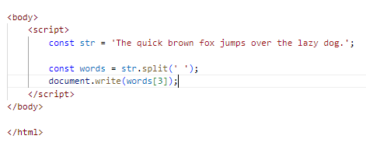

Output:



Q.63) Check if the string contains a word Script using includes() method?

Ans.63)

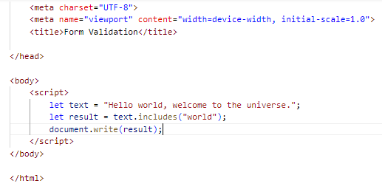

Output:



Q.64) Change all the string characters to lowercase letters using to Lowercase () Method.

Ans.64)

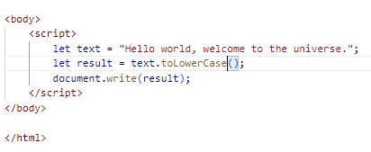

Output:



Q.65) What is Character at index 15 in ’30 Days of JavaScript’ string? Use char At () method.

Ans.65)

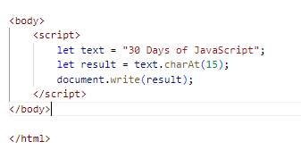

Output:



Q.66) copy to one string to another string in JS?

Ans.66)

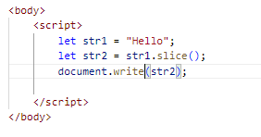

Output:

